**FEASIBILITY STUDY OF CO2 CONTROL IN AUTOMOBILE VEHICLES**

**INTRODUCTION**

Increase in vehicle population reflects the increase in the usage of fossil fuel consumption in the world. The statics shows that, currently in India the vehicle population increased by four times higher than compare with the year 2000. Fossil fuel consumption in India is also increased drastically related with vehicle population. Most of the automobile vehicles are energized with the diesel, gasoline, liquefied petroleum gas (LPG) and compressed natural gas(CNG). These carbon based fossil fuels has more impact on environment and human health, if the usage of these fuels is increased, then there will be increase in climatic change drastically. The best idea is to control co2 emission from fossil fuel combustion. At present many countries are taking steps to control CO2 emission from vehicles but they are not successful.

**WORLD SCENARIO WITH CO2 EMISSION**

CO2 is the most dangerous gas emission which absorbs and emits thermal radiation. CO2 is a greenhouse gas, which creates greenhouse effect. Along with greenhouse gas methane and NOX emissions are also present. Before UK was the first large scale CO2 emitter which is followed by US, China. By 2015 China has 15% of total cumulative CO2 emissions and India has 3% of total cumulative CO2 emissions. Total cumulative emissions are not emissions in particular year but cumulative sum of Country’s historical emissions which cause climatic change problem. The recent data from Global carbon project said that there 2.7% increase in emissions by 2018. Greenhouse gas contributes to global warming in which one tonne of methane does not have same impact on global warming compared to one tonne of CO2 emissions.At present China is the first CO2 emitter country because China has more population and it is followed by US, India, Russia, Indonesia, Brazil, Japan, Canada and mexico. In recent days high income nations have stabilized CO2 emissions but low to middle income economy nations emits more CO2. Emission considering all over the world increased from 2 billion tonnes of CO2 in 1990 to over 36 billion tonnes 115 years later. The CO2 emission in transport sector in worldwide is about 23%. In low and middle developing countries trucks and buses consume more fuel and emit more CO2. To control CO2  emissions some countries like China, Singapore, Hong kong has decided to shift the transport to low carbon emission for example instead of car or light truck , bus, metro can be used.

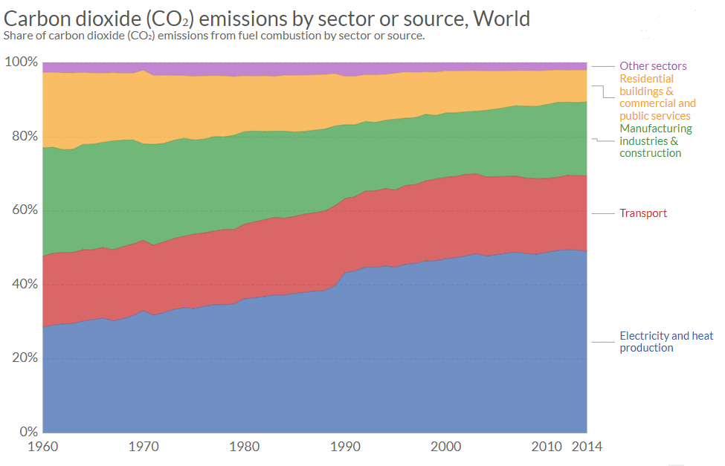

fig:1

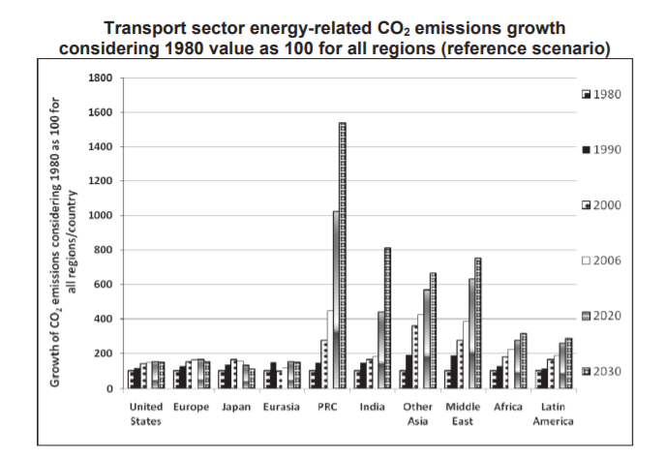

fig:2

|  |  |
| --- | --- |
| **COUNTRY** | **TOTAL CO2 EMISSIONS (million metric tonnes)** |
| China | 10,709.48 |
| United States Of America | 5011.69 |
| India | 2533.63 |
| Japan | 1239.60 |
| UK | 367.86 |
|  |  |

Table 1: CO2 emissions from different countries

**INDIAN SCENARIO WITH CO2 EMISSIONS**

In India the number of vehicles and their emissions in different state varies accordingly. Based on this Indian government takes measures to reduce CO2 emissions. A data from transport research wing from ministry of road transport highways presents that the total number of vehicles sold in the year 2012 is approximately 16 crores, which includes two wheelers, three wheelers, cars, jeeps, taxis buses and goods carrier vehicles. The total revenue from road vehicles is close to Rs.1,33,840 crores in the year 2012-13from sales tax, accessories and import & excise duty.

India CO2 emission is fourth largest in world. In 90’s government has increased number of road vehicles and in consecutive years it further increased and these vehicles consume non renewable fossil fuels which emit more greenhouse gases, particularly CO2 emission. The road transport sector has contributed about 94.5% and 53.3% of total transport emissions of CO2  and CO. Maharashta is the first CO2 emitter state in India (11.8%) and it is followed by Tamilnadu(10.8), Gujarat(9.6), Uttarpradesh(7.1%), Rajasthan(6.22%) and Karnataka(6.19%). In these six states 51.8% CO2 is from road transport .Thebelow table shows about CO2 emissions in different categories in India.

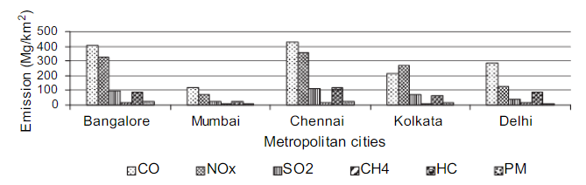

Fig 3: Vehicular Emissions in major metropolitan cities

|  |  |
| --- | --- |
| **CATEGORIES** | **CO2 EMISSIONS** |
| Bus | 28748.16 |
| Omni Buses | 8508.42 |
| Two Wheelers | 8701.08 |
| Light Motor Vehicles(Passengers) | 4378.10 |
| Car and Jeeps | 23901.22 |
| Taxi | 2367.08 |
| Trucks and Lorries | 70288.92 |
| Light Motor Vehicles(Goods) | 44654.48 |
| Trailers and Tractors | 46563.85 |
| Others | 5705.22 |

Table 2: Emissions from different types of vehicle in India

**EFFECT OF FOSSIL FUEL COMBUSTION AND ENGINE EXHAUST EMISSION**

The basic parameter that fuel should have is it should produce moderate amount of heat when it is combusted. Most of the fossil fuels are carbon based fuels and during proper combustion it produces more amounts of CO2 and an improper proper combustion produces carbon monoxide which is more hazardous to the environment. Combustion coal and diesel produces NOx and sulphur dioxide in addition to CO2. The emission from fossil fuel combustion creates more health problems like cancer, mental health problem, asthma, infectious disease, psychological trauma, etc. The increase in amount of CO2 causes earth to warm and the oceans to become more acidic. The major source of global air pollution and CO2 emissions is gasoline, diesel, coal, natural gas in addition to CO2 it also emits hydrocarbon, nitrogen, sulphur dioxide and volatile chemical from O3. For last six decades emission from fossil fuel combustion is more which results in greenhouse gas and the pollutants affects the environment and there will be more climatic changes. From 1990 to 2016 greenhouse gas is increased to 40%. By using natural gas air pollution can be decreased to some extent but during transportation of methane if leakage occurs, it is 34 times more dangerous than CO2. Coal consumption declines between 2015 to 2021.

**CO2 SHARE BY CARBON BASED FUELS**

When engine moves vehicle down the road convert the energy stored in fuel into mechanical energy which drive wheels and this process produce CO2. Burning 1 litre of gasoline produces approximately 2.3kg of CO2. Normally when 2000 litre gasoline is burned every year and releases about 4600kg of CO2. 1 litre of gasoline which have 0.75kg of weight produces 2.3kg of CO2 because gasoline composed of hydrogen and carbon during combustion, the carbon from fuel combine with O2 to produce CO2 , so this weight comes from O2.

CXHY + O2+ Spark H2O + CO2+Heat

During combustion hydrogen from fuel and oxygen from air gives water and similarly carbon from fuel and oxygen from air gives carbon dioxide and the generated heat gives mechanical energy, therefore oxygen from air makes exhaust gas heavier. For denser hydrocarbon fuels like diesel which has more carbon produce more carbon dioxide for the given volume of fuel. Gasoline is a complex mixture with several types of hydrocarbon molecules. It varies with crude source, age of product, storage condition. If hydrocarbon is not fully oxidized it produces carbon monoxide.

|  |  |
| --- | --- |
| **FUEL TYPE** | **Kg OF CO2 PER UNIT** |
| Natural gas | 3142 per tonne |
| Diesel fuel | 2.68/litre |
| Petrol | 2.31/litre |
| coal | 2419/tonne |

Table 3: CO2 per unit for carbon based fuels

|  |  |
| --- | --- |
| **FUEL TYPE** | **CO2 TAILPIPE EMISSION(kg/l)** |
| Gasoline | 2.29 |
| E10( 10% ethanol and 90% gasoline) | 2.21 |
| E85(85% ethanol and 15% gasoline) | 1.61 |
| Diesel | 2.65 |
| B5(5% biodiesel and 95% diesel) | 2.65 |
| B20(20% biodiesel and 60% diesel) | 2.62 |

Table 4: CO2 tailpipe emissions

|  |  |  |
| --- | --- | --- |
| **CARBODIOXIDE FACTORS** | **POUNDS CO2**  **(per unit volume or mass)** | **KILOGRAMS CO2**  **(volume or mass)** |
| Propane | 12.70/gallon | 5.76/gallon |
| Butane | 14.80/gallon | 6.71/gallon |
| Butane/Propane mix | 13.70/gallon | 6.21/gallon |
| Home heating and Diesel fuel(Distillate) | 22.40/gallon | 10.16/gallon |
| Kerosene | 21.50/gallon | 9.75/gallon |
| Coal(all types) | 4631.50/short ton | 2100.82/ short ton |
| Natural gas | 117.10/thousand cubic feet | 53.12/thousand cubic feet |
| Gasoline | 19.60/gallon | 8.89/gallon |

Table 5: carbondioxide emission coefficients

**CO2 EMISSION IN VEHICLES**

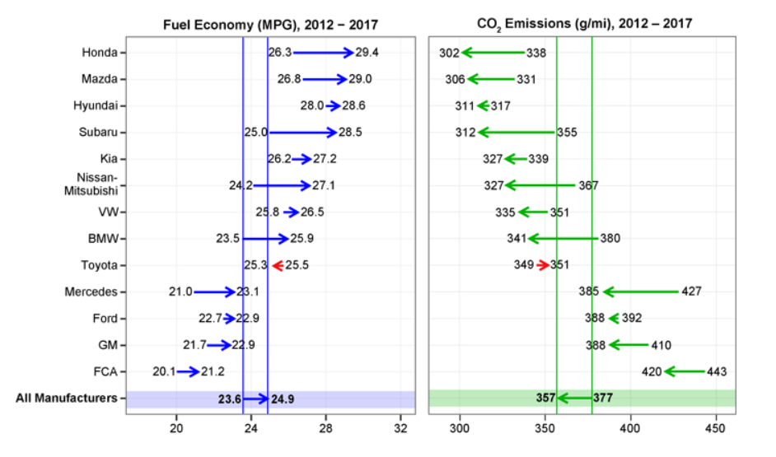

Fig 4: Changes in estimated real world fuel economy and CO2 for large manufacturers

Automobile sector is also a major part in CO2 emission in addition to industries. The average gasoline vehicle has a fuel economy of about 22 miles/gallon and drives around 11,500 miles per year, when every gallon of gasoline burns it creates about 8887 grams of CO2. A normal passenger vehicle emits about 4.6 metric tons of carbon dioxide per year. CO2 emitted by tailpipe for driving one mile is 404 grams. Mostly the vehicles create tailpipe gas emissions, by distributing the fuel to vehicle power is generated but it also creates greenhouse gas. Electric vehicle has no tail pipe emissions but the production and distribution of electricity used to fuel the vehicle will create emissions. In the year 2017 Honda has led the industry with lowest CO2 emissions and highest fuel economy.

**STRATEGIES TAKEN BY INDIAN GOVERNMENT TO REDUCE CO2**

India is facing many challenges for low energy transformation. Like other countries India also taking some initiatives to reduce carbon dioxide emissions. Natural Resource Defense Council (NRDC) builds low carbon based economy in 2009. NRDC works mainly in four major projects. They are strengthening environmental governance, US India collaboration to enhance climatic change, public health impacts by enhancing climatic change, increasing building efficiency. India has put forward in reduction emission intensity of 33-35% by 2030 from 2005 levels. Indian government has decided to use no fossil fuel energy to reduce CO2 emission in electicity generation by 2030. Indian railways is a largest electricity consumer they are trying to reduce carbon emissions as well as to improve energy by reducing fossil fuels and increasing renewable energy capacity. International energy agency (IEA) has introduced some policies to reduce emissions. Central electricity authority of India also stated that after 2022 there will no more coal plants needed by the country so carbon emissions may be decreases. National determined contribution(NDC) are also ambitious to reduce emissions by using renewable energy. IRADE and IEA are targeting to use 100% renewable energy source to control emissions. By skipping bharat V emission standard bharat VI emission standard will be implemented by 2020 to reduce emissions. According to India’s Biennial Update report (BUR) to reduce industrial carbon intensity by 30% as in 2005, we can achieve this by 2.5 billion tonnes of carbon sequestration through tree plantation. This should be achieved by 2030. India’s CO2 emission is predicted to increase 6.3% in 2018.

**FEASIBLE TECHNOLOGIES CONTROLLING CO2 EMISSIONS**

Now a days global warming is a major issue due to greenhouse gas emissions, because of many industrial process like power plants, oil refineries, fertilizers, cement and steel plants which produces more amount of CO2. To prevent the climatic change due to CO2 emissions some approaches are taken by different countries like reduction of consumption of energy generated by fossil fuels, generating energy by using non fossil fuel energy sources like nuclear energy, solar energy, wind energy and using carbon capture and storage technology. In CCS technology CO2 is separated from the source and used either in other processes or it is stored in underground and ocean storage. Three process in CCS technology is capture, transport and storage. The three main process to reduce CO2 combustions post combustion, precombustion and oxyfuel combustion. In oxyfuel combustion no extra solvents are needed, it is a simple mainly consists of compression and cooling steps.

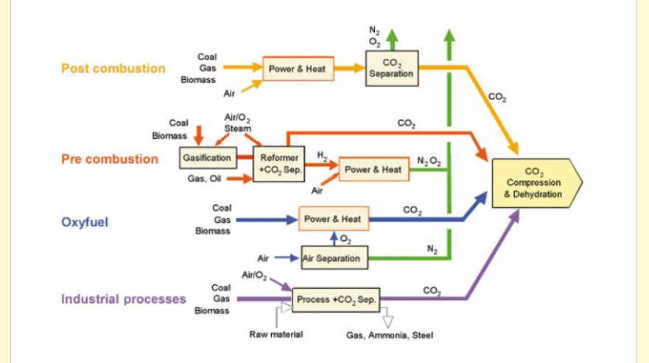

Fig 5: CO2 capture technologies

Rock have enough millimeters sized voids or pores which have capacity to store CO2. The pores in the rocks are feasibly connected so they have capability to accept CO2 when it is injected and it spreads. There will be barrier or caprock at the top which helps to store CO2 permanently. Some carbon storage methods are deep saline formation to store CO2 permanently. Coal-bed methane, in this CO2 is injected into the coalbed to exchange CO2 with methane, currently this method is in research and it is not under operation. Another method is EOR ,CO2 is injected to increase oil production. Some depleted oil or gas fields can’t be used for oil or gas production but they can be used for storage.

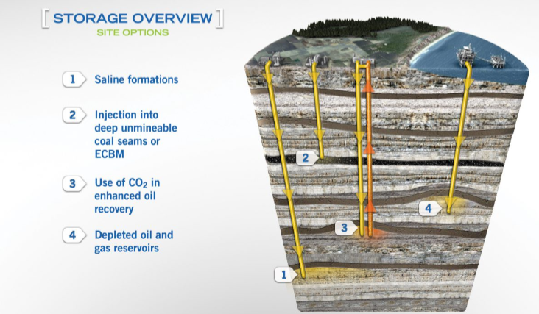

Fig 6: Geological storage of CO2

To inject CO2 underground, CO2 is compressed into a fluid before injection of carbon dioxide the pores in underground are filled with fluid like oil, gas or salty water and then carbon dioxide is injected.